Student Responsibilities  1. Remember to go to check-in and check- out in Room _____.  2. Keep track of CICO card.  3. Be safe while walking to CICO room.  4. Bring signed home report every day.  Teacher Responsibilities  1. Provide a rating at designated times.  2. Provide reminders to attend check in and check out.  3. Provide support and encouragement to the student.  4. Provide updates to CICO staff.  CICO Staff Responsibilities  1. Check students in and out.  2. Provide CICO cards and home report.  3. Provide updates to classroom teachers. |  | Why Try CICO?  *Helps students to self-monitor and correct.  *Improves and establishes daily home/school communication and collaboration.  *Improves student organization, motivation, incentive, and reward. ·  *Provides feedback and adult support on a daily basis. |  |  |   
 | 

CICO

(Check-In, Check-Out)

Wickman Elementary School

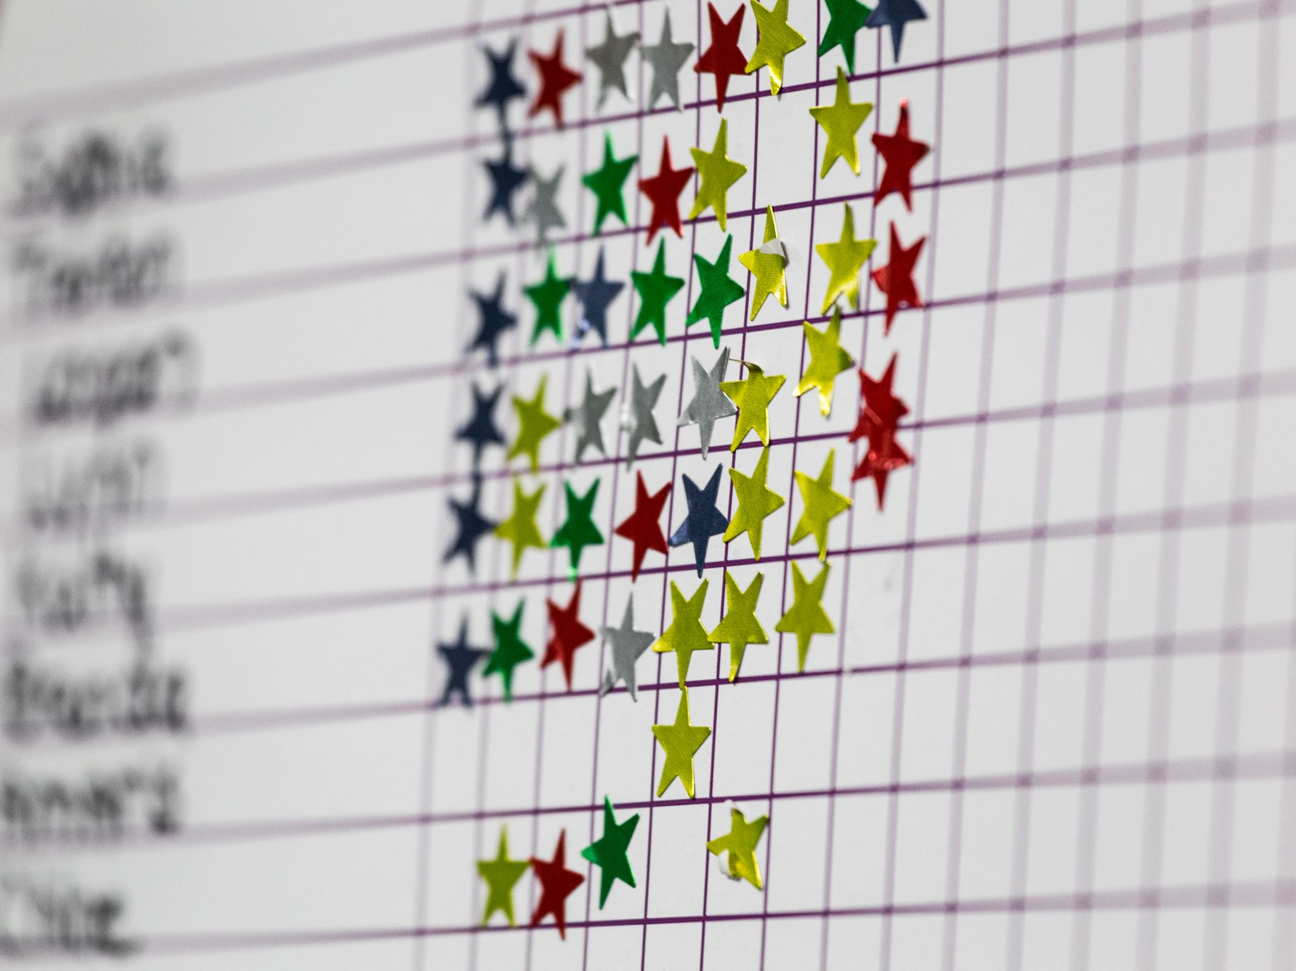 |  | Benefits of CICO  Through this program, your child will receive multiple opportunities to positively interact with invested adults at school. Your child will benefit from recurring feedback regarding his/her behavior, positive adult attention, and positive reinforcement for exhibiting the desired pro-social behaviors.  Fading Out  Fading refers to a process of gradually removing CICO intervention components for students who have met program goals. Students may be faded from an intervention when they have shown sufficient progress and are meeting at least 70% of the total possible points on a daily basis for at least 6-8 weeks. Fading removes the intervention gradually as the student learns to self-monitor. |  |  | Research shows that programs like CICO are most successful when the home and school work collaboratively together to support the child. Keep the interactions positive: celebrating the successes, briefly noting the pitfalls, and avoiding contingent consequences.
How does CICO work?  A student checks in with a designated adult at the start of the school day. The adult gives the student a point sheet that lists the goals the student is working on. The adult reminds them on what they need to focus on and encourages the student to work towards their goals. The student’s teacher will monitor student progress and document student progress on the point sheet.  At the end of the day, the student checks out with the same adult they checked in with. The adult talks with the student asking how they did, what went well and what they need to improve upon.  The student takes the point sheet home to show and discuss with their parent(s). Parents are to encourage the student and not say negative or blaming comments. |  |  |  |  | Parent Tips with CICO  1. Ask your child if the daily goal was met.  2. If goal was met provide designated home acknowledgement/reinforcement.  3. If goal was not met, give corrective feedback and encouragement. Ask: “What do you need to do differently tomorrow?” “Is there anything I can do to help you with this?” “I know you can meet your goal tomorrow.”  4. Sign the daily progress report and remind student to return it to school.  5. Keep interaction and instruction brief.  6. Use a positive tone throughout the interaction.
 |  | 

